It’s GoNNA Get BETTER  
Project Report

WeFixStuff

Hua Yao

Nawad Shabbir

Tara Singh

Vivekanandhan Kannan

Mayunk Bhangu

Table of Contents

Section 1: Business Problem 2

Section 1.1: Company Overview 2

Section 1.2: Business Objectives 2

Section 1.3: Situation Analysis 3

Section 1.4: Feasibility & Viability 3

[Section 2: Analytical Objectives] 3](#_Toc34246205)

Section 2.1: Descriptive Analytical Objectives 3

Section 2.2: Hypothesis Testing Objectives 4

Section 2.3: Predictive Modeling Objectives 4

Section 3: Data Preparation 4

Section 3.1: Data Overview 4

Section 3.2: Bivariate Analysis 6

Section 3.3: Multivariate Analysis 13

Section 4: Model Development 17

Section 4.1: Partition Data, Training and Validation Tests 17

Section 5: Solution Deployment 17

Section 5.1: Answers to Descriptive Analytical Objectives 17

Section 5.2: Answers to Hypothesis Testing Objectives 18

Section 5.3: Answers to Predictive Modeling Objectives 18

Section 5.4: Model Maintenance 19

Section 5.5: Cost benefit Analysis 19

Section 5.6: Additional Monthly Services Provided by WFS 20

Section 6: Conclusion 20

Section 7: Reference 20

# Section 1: Business Problem

## Section 1.1: Company Overview

* Its Gonna Get Better (IGGB) is a Telecom company which serves North America for the last 25 years. The company provides various support to homes and businesses and currently has 25 million customers and is listed as a Fortune 500 company. IGGB employs approximately 9000 people across the region. The company is headed by Phil who is CEO, he has 25 years of experience in the telecom business and he provides strategy to the Board of Directors regarding company market share and business growth. Mike is the CFO and he ensures the current and future financial stability.

## Section 1.2: Business Objectives

* Determine the company’s strengths and areas of opportunity with respect to churn
* Achieve the industry average churn rate of 15% within the next five years
* To reduce and prevent customer churn over the next five years
* To identify the sources of potential churn
* To increase revenue and market share / competitive presence
* Maintain the current clients’ business on an ongoing basis

The Executive team decided to use Data Analytics to determine the root causes for customer churn. They decided to hand over this job to Chief Marketing Officer, Tony. Tony believes that Data Analytics will resolve customer churn, which will impact IGGB positively.

## Section 1.3: Situation Analysis

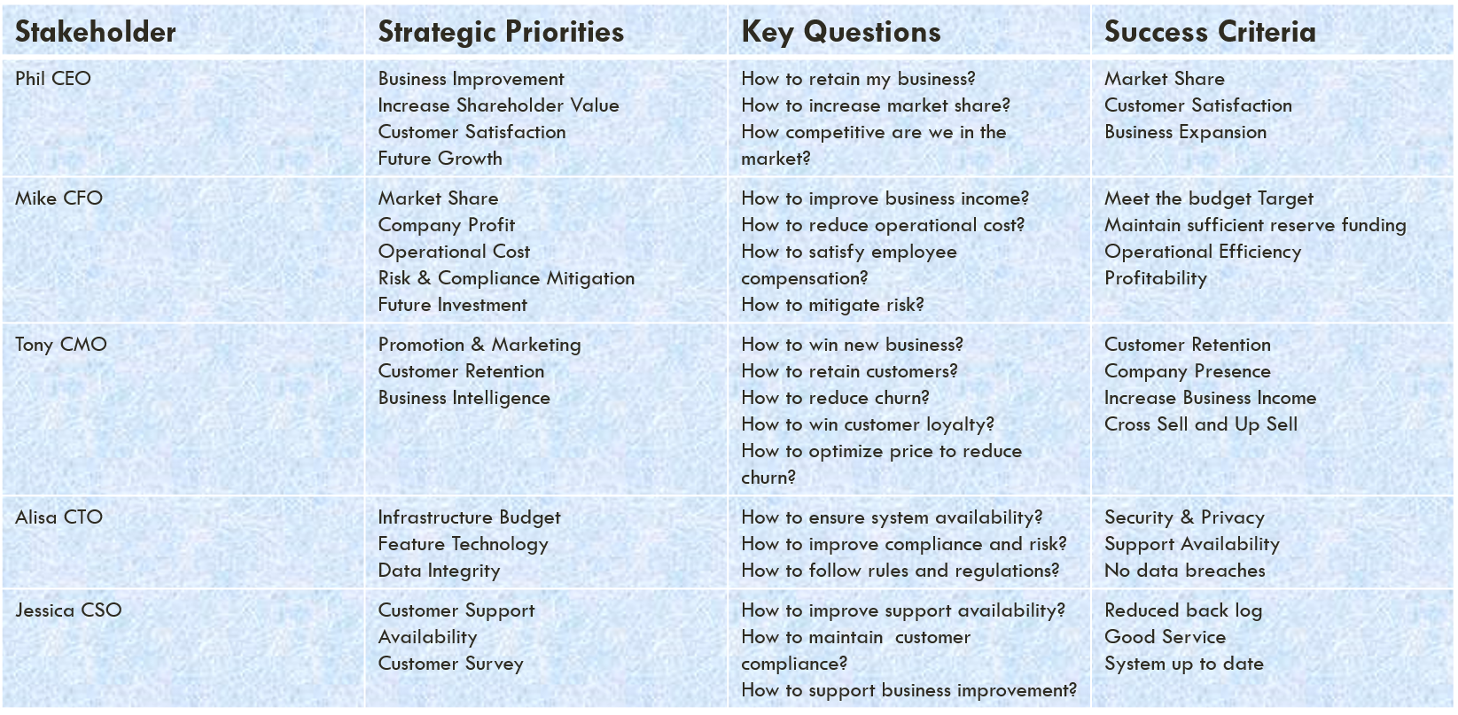

## Section 1.4: Feasibility & Viability

* The needs of the stakeholders vary widely. Since IGGB has been in business for long time and servicing many customers, it is challenging to arrive at a well-defined business solution. The available resources and support from stakeholders give confidence to WFS to provide the best business solutions for customer churn. The goal is to identify what is causing customer churn, so that IGGB can reduce it over the next five years. There is enough available customer data to analyze and determine the root causes of the customer churn and improve market share and profits for IGGB.

# Section 2: Analytical Objectives]

## Section 2.1: Descriptive Analytical Objectives

* + - Which segments of customers are likely to churn?
    - Why are they likely to churn?
    - What are the root causes of the churn?
    - What is the profile of retained customers?

## Section 2.2: Hypothesis Testing Objectives

* + - Does the number of products help to retain customers?
    - Is pricing a factor?
    - What are the core products?
    - What are core services?

## Section 2.3: Predictive Modeling Objectives

* + - A cost decrease would improve customer retention
    - Increasing the number of services will improve customer retention
    - Can we predict how many customers going to leave in future?
    - Can we predict how business services impact customer churn?

# Section 3: Data Preparation

## Section 3.1: Data Overview

WFS have approached IGGB to get any available data sets that provide the relevant customer information. After the initial analysis, we determined:

A file with 7,043 records and 21 variables

A variety of variables such as:

* + - Customer – customer ID, gender, partner, dependents, tenure,
    - Type of services – phone, multiple lines, streaming movies, device protection, online backup etc.
    - Billing and payments – paperless billing, payment method, total monthly charges etc.

Based on data set analysis we have a better understanding of how to arrive at the best analytic solution to reduce customer churn.

During initial analysis we made following observations:

* Looked at data outliers
* We found 11 clients who had no data for total charges and tenure of 0 months. This represents less than half a percent which has no significant impact.

We assumed that these clients were brand new and had not yet been billed or were clients who stayed less than one month. Another possibility is that they were given a free promotional offer for a limited time period which they did not keep after the promotional period. WFS decided to keep these 11 clients as part of the analysis.

* No duplicates found in the data – using the Customer ID field as the identifier / differentiator
* Identified relationship between data and key variables
* Understand customer profiles and behavioral patterns
* Fine tuning the data to eliminate duplicates and dealing with outliers and missing values
* Partitioned Data into Decision tree to obtain samples to start work on analysis
* 1869 churned customers from Overall sample data set
* Three Numerical key variables like Tenure, Total charges and Monthly charges
* 18 Categorical variables out of 21 variables

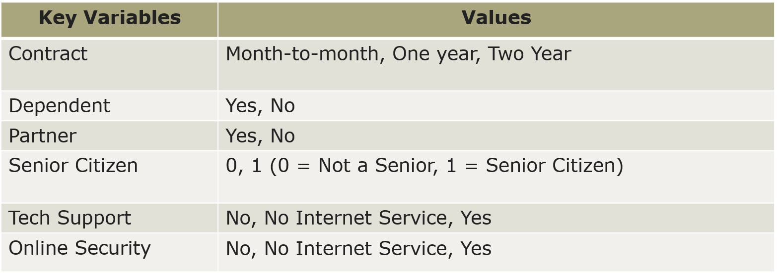

## Section 3.2: Bivariate Analysis

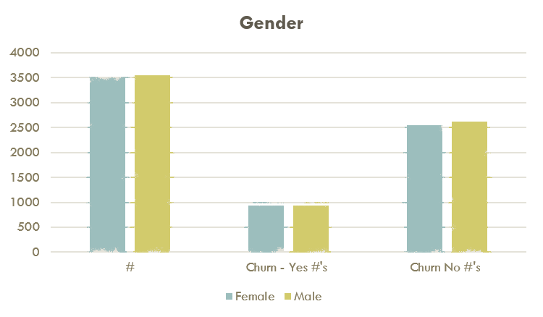

Gender doesn’t appear to be a factor in churn as it’s equally distributed between male and female. Ethically, we also shouldn’t consider gender as a relevant variable.

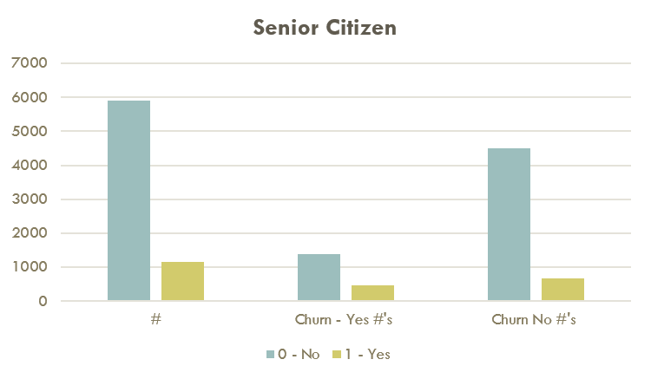

The overwhelming majority of the client base (83.79%) are not Senior Citizens.

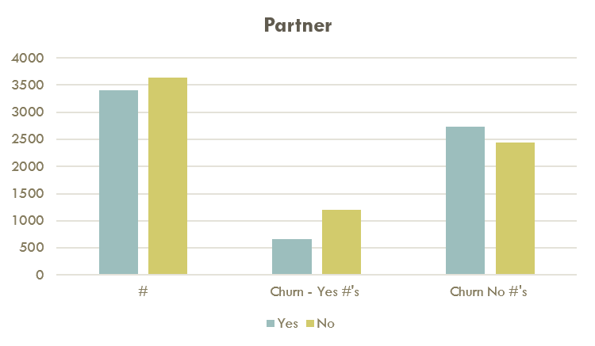

Clients with no partner are more likely to churn. We reasoned that it’s because there is no second opinion to influence that decision.

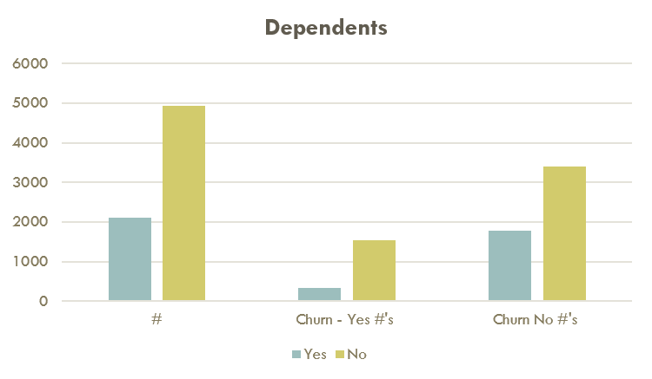

Most of the client base (70.04%) do not have dependents.

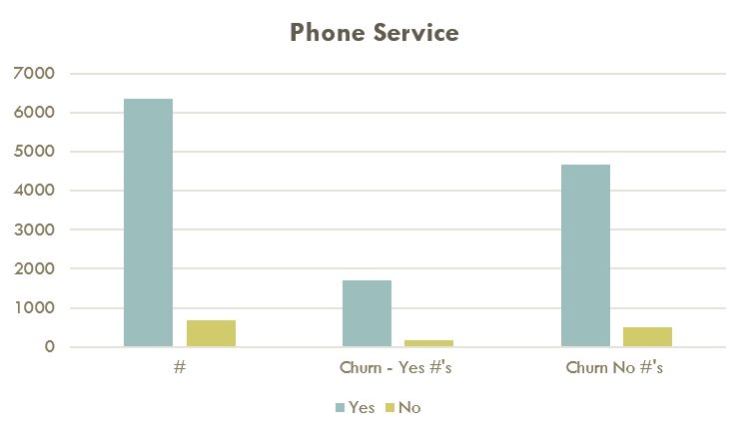

The majority of the client base have phone service and do not tend to churn

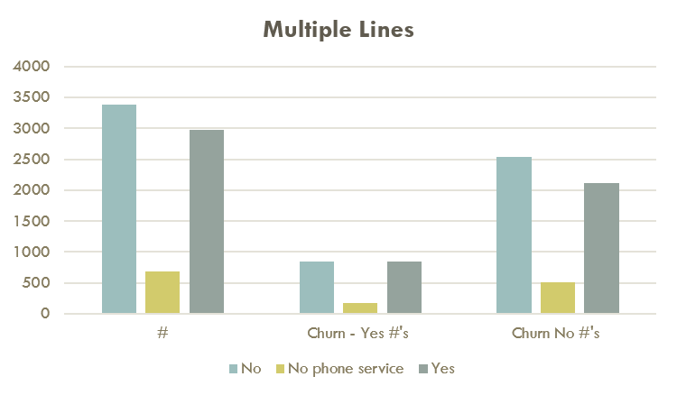

Churn doesn’t appear to be related to multiple phone lines.

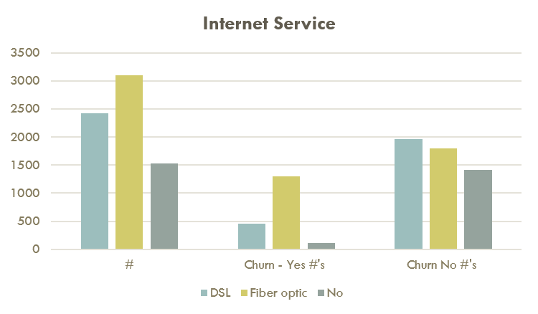

A high number of Fiber Optic clients (69.4%) are churning.

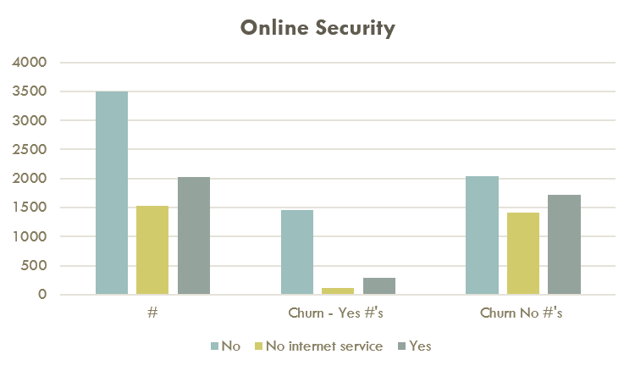

Client’s who do not have online security (78.17%) are churning.

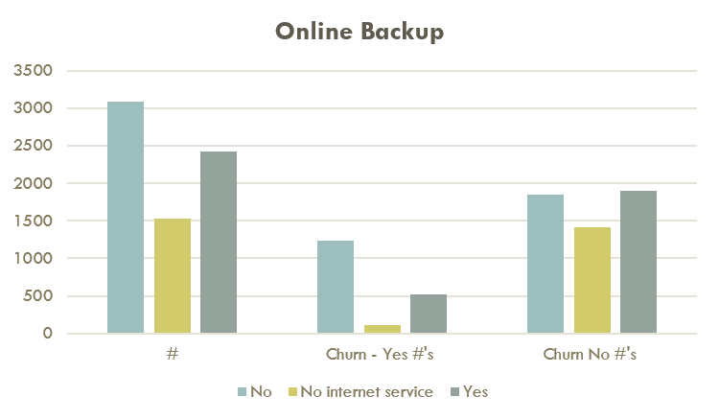

Clients who do not have online backup (65.97%) tend to churn.

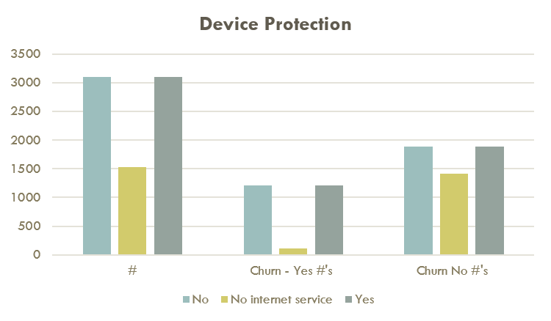

Device protection does not appear to be a factor in churn as the graphs are evenly distribution between churn and no churn.

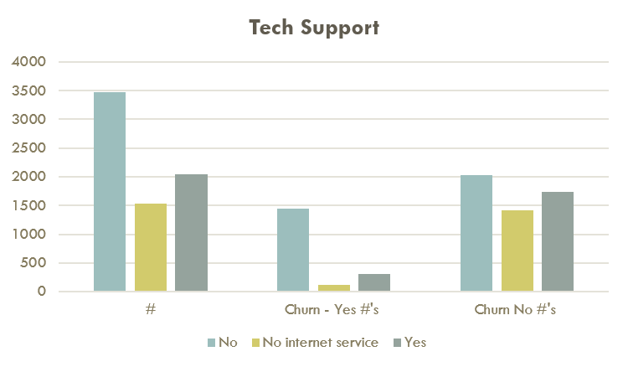

Clients who do not have tech support (77.37%) tend to churn. Tech support is a major variable in contributing towards customer churn.

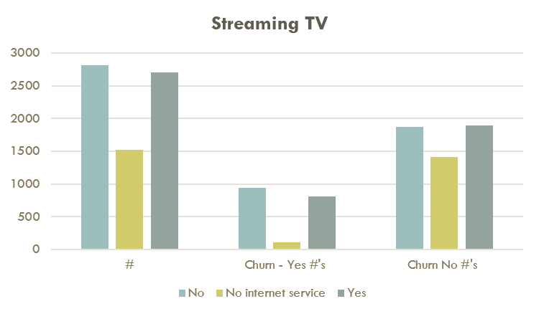

A slightly higher number of clients who do not have streaming TV are churning.

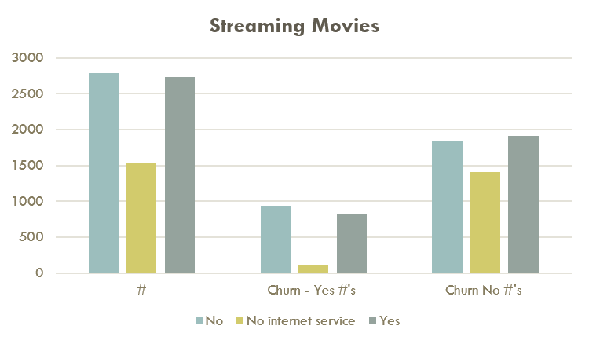

A slightly higher number of clients who do not have streaming movies are churning. This is very similar to the data for streaming TV.

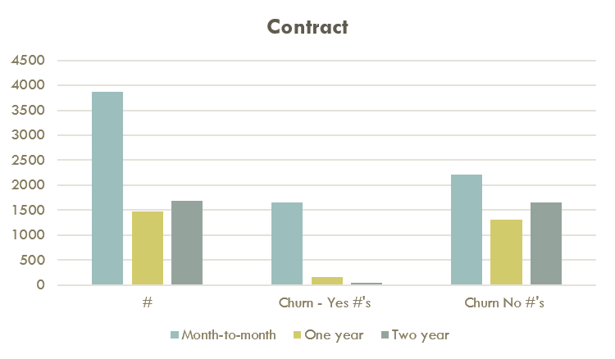

A significant number of clients who are month-to-month (88.55%) are churning. This a major contributing factor to customer churn.

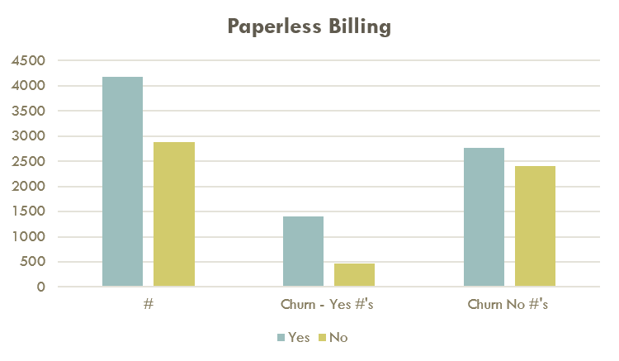

A higher number of clients who receive paperless billing (74.91%) are churning.

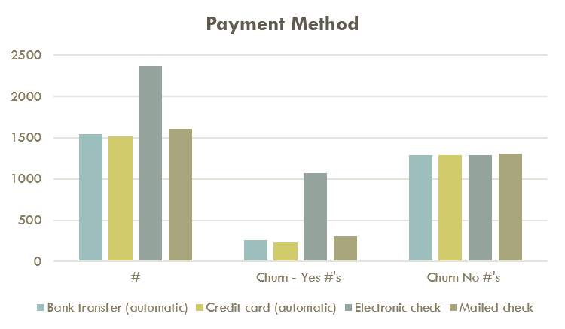

A significant number of clients who pay by electronic check (57.30%) are churning.

## Section 3.3: Multivariate Analysis

The below seven charts show churned and not churned customers of IGGB over the tenure of 72 months. The vertical axis shows the number of customers. Each chart shows breakdown of the number of churned and not churned customers based on how many months they have been with IGGB. In addition, each tenure like 24 months is broken down further into type of contract the customer is on. The first of 7 slides show the breakdown over 72 months. The remaining six charts that follow are showing a breakdown based on a tenure of yearly.

The following multivariate charts depict the relationship between the amount of churn, tenure and contract type “month-to-month” from year 1 to year 6.

We can clearly see that the churn is the highest in year 1, and more specifically for customers who have been with the company for less than 3 months.  Also, to note is that the churn is the highest for customers who are on month-to-month contract.  We also see that there is a drastic decline in churn with each additional year the customers stay with the company.  This tells us, that we should do our best to incentivize our month to month contract customers to go with longer term contracts, thereby reducing the likelihood of churn by a significant amount.

Tenure

Tenure

Tenure

Tenure

Tenure

WFS has noticed a general trend of decreasing number of customers churning over the seven charts (72-month period). We have noticed that if the customer is happy with the service being provided, they are less likely to churn and the type of contract that they are on does not matter.

# Section 4: Model Development

## Section 4.1: Partition Data, Training and Validation Tests

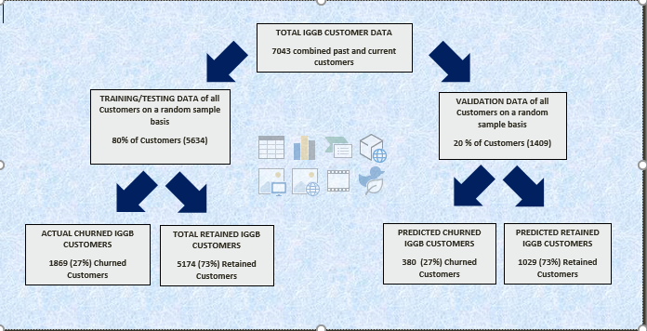

We did not break down the data into two subsets (churn / No Churn) because the data is too small to begin with. If we were to make our model flexible and reliable, we would use 80% of the data for training and 20% for validation. This would minimize errors and does not memorize.

# Section 5: Solution Deployment

## Section 5.1: Answers to Descriptive Analytical Objectives

* + - Which segments of customers are likely to churn?

Month-to-month

IGGB’s current customers that are month-to-month are also a high risk to churn. Customers that month-to-month churn because they have the freedom to change providers at moment’s notice without being penalized a cancellation charge.

Paperless billing

Customers that select paperless billing are churning at a high rate. We reason that this due to customers forgetting to pay the monthly bill on time and thus are charged interest. Customers that constantly forget to check their email for the bill are paying late with interest, get tired of being charged interest.

Payment Method-Electronic cheques

Customers that pay via electronic cheque are more likely to churn due to ease of payment. It makes it simple, fast and far to easy to change service providers at a moment's notice. These customers are likely also receive their bills by a paperless method.

Streaming Tv and Movies

We found similar churn data for streaming TV and streaming movies.

Fiber Optics

We found that a high number of fiber optic customers were churning.

Tenure

Based off total sample data provided, our analysis indicates that customers with a tenure of three months or less are churning at a high rate.

* + - Why are they likely to churn?

Not on a contract. Paperless billing. Payment by electronic cheque.

* + - What is IGGB doing well to retain customers?

The customers those who are using the following services are staying longer with IGGB

Phone Services and Multiple lines. Customers on contract are staying because they are locked in. IGGB should provide bundles on contract terms so that customer are retained for longer period.

## Section 5.2: Answers to Hypothesis Testing Objectives

* + - Does the number of products help to retain customers?

Bundle Services are showing significant improvement to retain customers

* + - Is pricing a factor?

Pricing doesn't appear to be a factor in customer churn.

* + - What are core services?

Phone service and Internet service are core services. Streaming TV, Streaming movies, Online backup, online security all depend on that.

## Section 5.3: Answers to Predictive Modeling Objectives

* + - A cost decrease would improve customer retention
    - Increasing the number of services will improve customer retention
    - Can we predict how many customers going to leave in future?
    - Can we predict how business services impact customer churn?

We have yet to create models to answer the predictive modeling objective questions stated above.

## Section 5.4: Model Maintenance

In order to maintain the model, we will need to constantly run tests on a monthly basis to ensure the model is reacting correctly. In addition, the model will need to be updated to continue its balancing act with new services being offered by IGGB in the future and any promotional offers.

## Section 5.5: Cost benefit Analysis

Cost benefit analysis done based on Churn customers (27%).

## 

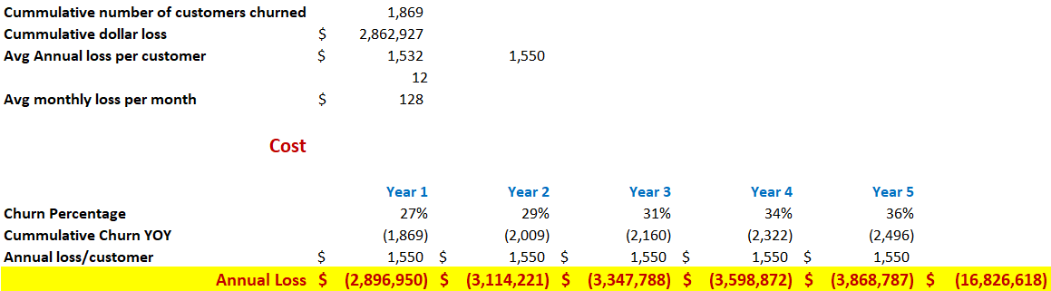

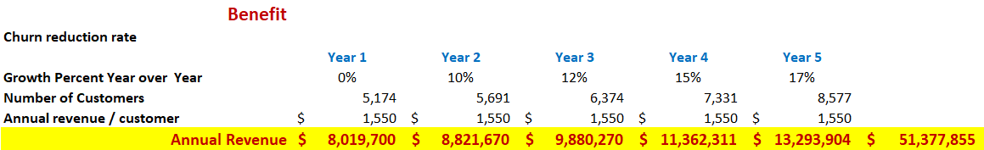

## Section 5.6: Additional Monthly Services Provided by WFS

* Monthly KPI Reports
* Business Intelligence and competitive market analysis
* Apply Data analytics to other departments in IGGB to make more informed and timely decisions
* Make strategic recommendations based on data analysis

## Section 6: Conclusion

By engaging the services of WFS, your churn will be reduced over the next five years at a gradual pace, while being monitored throughout. By implementing our recommendations; the number of customers retained will increased, revenues collected will increase and IGGB’s market share will increase. IGGB’s market share will increase because it will do better than business analysists expectations on a quarterly/ yearly basis. With the increase revenue IGGB will have more money available to improve its core services and invest in future telecom technology. By providing meaningful bundles, customers satisfaction will increase, which will help develop longer term customer tenure. Bundles will help attract new customers by offering multiple services at discounted rate. Once IGGB starts to see these positive changes, you will begin to realize the power of data analytics. The success of this project will influence IGGB to partner with WFS to leverage data analytics.

## Section 7: Reference

<http://www.dbmarketing.com/telecom/churnreduction.html>